A Brief History

Since 2006 a group from Grace United Church has travelled to Honduras in partnership with Friends of Honduran Children. Our groups’ main mission is to support and help the children in the Nuevo Paraiso orphanage. We also travel into the mountains and visit rural schools delivering much needed school supplies and food bags.
Prior to the trip a building project is chosen along with the guidance of a team on the ground in Honduras. To date we have built 3 homes for the children at Nuevo Paraiso, 6 school rooms in the mountain regions, 1 prefab houses in a nearby village. Two years ago our project was a medical centre giving care to 1000’s of local people without access to any form of medical help.
Our 2018 project is to build new washrooms at the elementary school at the Nuevo Paraiso compound.
We are grateful to Grace United Church for their continued support and each year we hold many fundraising events that allow us to purchase the supplies we take with us & the many items purchased in Honduras. Our September yard & plant sale is now a south end Peterborough tradition for many families.
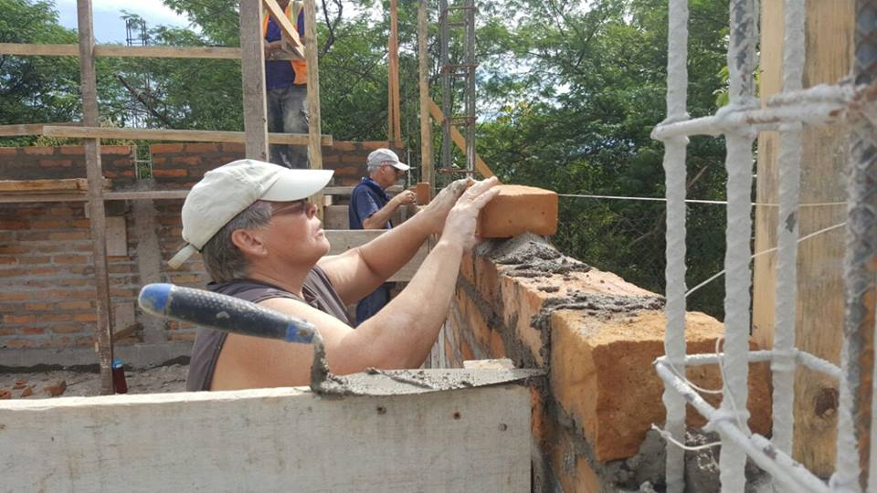

Each brigadier is responsible for funding their own trip; many of us rely on the help of friends and family members. Some of us have been with the group from the beginning, others for a year or so. Everyone however has been touched by the love and gratitude of the Honduran people we meet. Friendships that will last a lifetime are made; many of us sponsor a child in the orphanage. What a joy to see your child grow and become a valued member of their community.
We are passionate and proud of the amazing things we have accomplished and hope you will find in your heart the willingness to give what you can to these beautiful children.

Friends of Honduras Children

Founded in 1979 by Dr. Jim McCallum upon returning from a medical brigade to Honduras. There he met Sister Maria Rosa & saw the horrible conditions the children faced every day.

How Can You Help??

Even the smallest of donation will make a difference in the lives of the children. You
will be helping us to

- Purchase school supplies
- Make foods bags for the rural school families
- Help with small repairs to the homes at Nuevo Paraiso
- Make sure each child has a proper fitting school uniform and shoes
- Provide the kids with vitamins and basic medical needs
- Purchase formula & other infant needs

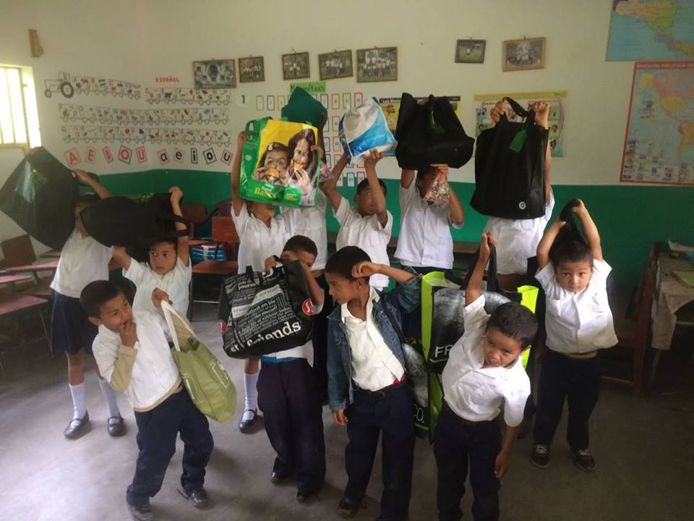

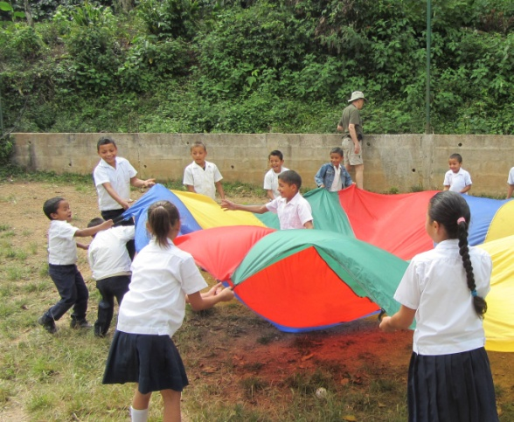
It’s not how much we give but how much love we put into giving
“Mother Teresa”

Monetary donations are accepted any time through our Friends of Honduran Children – Canada Helps page at: www.canadahelps.org (Search: Friends of Honduran Children). Follow the prompts to donate to the Grace United Brigade or the name of the brigadier you wish to help. If any assistance is needed, contact Heather at FOHC 705-749-1900.

Log into the Friends webpage and follow the instructions to donate or purchase items from their online catalogue:
www.honduranchildren.com

Tax receipts will be issued for donations made thru either of these online pages. Be assured that 100% of your donation goes directly to the children.

Donations of school supplies, kids’ vitamins and new or gently used summer clothes can be dropped off at the church at 581 Howden Street Peterborough between 9:00 – 3:00 weekdays.

For more information please
contact one of the following
Brigade members:
Jane Bleecker 705-743-7150
bleeckerjane@gmail.com
Tom & Betty Jenkins 705 745 1189
tomjenkins@sympatico.ca
Friends of Honduran Children
www.honduranchildren.com
705-749-1900

G P I F

Grace Partnership in Faith

Honduras Build Trip 2018

2018 Trip Dates
16th Nov to 27th Nov

